Concept Lesson

Author: Jackson Ray

Date Created: 2/6/13

Subject(s): World History

Topic or Unit of Study (Title): Alexander the Great & Hellenic Culture

Grade Level: 9th Grade

Materials: paper and pencil for students, slideshow of Hellenic culture related things (see other document)

Summary (and Rationale): Alexander’s Empire spread Greek culture throughout most of the ancient near east and this had a lasting impact on the development of science, art, and philosophy.

I. Focus and Review (Establish Prior Knowledge): In our last class we discussed the geographic factors that affected the rise of the Greeks, what made Athens and Sparta unique, and how these factors grew into the Peloponnesian War. Today we are going to talk about what happened after Athens and Sparta were weakened by war and how Greek culture came to dominate much of the known world of the time. [2 min]

II. Statement of Instructional Objective(s) and Assessments:

Objectives | Assessments
Students will know Alexander the Great's date of birth, birth place, and his citizenship. Students will then be able to explain at least 7 major accomplishments of Alexander the Great and his empire. | Students will demonstrate this knowledge by identifying 7 major accomplishments of Alexander the Great, along with background information like place of birth, in their Resume activity. See rubric.
Students will have an understanding about what Hellenic culture was, how it developed, and important cultural aspects and be able to identify examples of Hellenic culture 70%. | By participating in the Concept Development activity, taking notes about the examples during the slideshow, and showing them as their ticket out the door, students demonstrate an understanding of Hellenic culture.

State the objective: [1 min]
Assessment: [60 min]

III. Teacher Input (Present tasks, information and guidance): [70 min]
Part 1) Lecture about Philip’s conquering of Greece, his son Alexander’s conquests in Persia and further into India, and how these cultures began to blend to form Hellenic culture. Lecture outline found on eduplace.com [25 min] (Eduplace.com)

Part 2) Concept Development activity asking “What is Hellenistic Culture?” Following the lecture students will take 5 min to write out several things, people, or concepts that come to mind when they think about Hellenistic culture, this is partially based off of the assigned section of reading from the night before. After each student has their list the class will spend about 10 min compiling them into a list on the board, and every student is responsible for at least one item. Then the list on the board will be broken down into groups of similar items which will then be used to formulate a class definition of Hellenistic culture, this should take about 10 min. Ideally this process will be primarily student driven, but I will nudge the students in the right direction if they get stuck or get too far off track. Janna Robertson Plagiarism Activity [25 min]

Part 3) Concept Development wrap up, participation activity. Once the class has an established definition of Hellenic culture I will pull up a slideshow of various pieces of art, scientists, places, discoveries etc. and as a class we will see how they fit into our definition, and if our definition is inclusive enough. Students will also be taking notes about each example. See the final page for examples of the kinds of images I would use. [20 min]

IV. Guided Practice (Elicit performance): [15 min]
After the class has learned about Alexander the Great and completed the Hellenistic culture activity the students will begin working on creating an historical resume for Alexander the Great. The students will imagine that they are Alexander the Great just before his death. Alexander is tired of ruling his empire and would like to apply to be the leader of another somewhere in the world. The resume can be written up in various ways but must contain the following, name, date of birth, place of birth, citizenship. There must be a section describing employment experience (achievements of his empire). (Gunnell, 2012).
http://rubistar.4teachers.org/index.php?screen=PrintRubric&rubric_id=2284686&

V. Closure (Plan for maintenance): [2 min]
Before students pack up to leave I will provide opportunity to ask questions about the material covered or about the assignment. Before students leave they will have to show me their notes from the Concept Development activity as their ticket out the door.

VI. Independent Practice: [0 min]
Homework will be to finish the resume assignment from the guided practice section.

STANDARDS:
WH.H.2.4
Analyze the rise and spread of various empires in terms of influence, achievements and lasting impact (e.g., Mongol, Mughal, Ottoman, Ming, Mesoamerica, Inca, Imperial states in Africa, etc.).
WH.H.2.9
Evaluate the achievements of ancient civilizations in terms of their enduring cultural impact.

Plans for Individual Differences: The blend of note taking, critical thinking during the concept development activity, class discussion of the images, and written resume assignment provide something for a wide variety of learning styles.

References (APA style):
Gunnell, Noreen. A Comprehensive Lesson Plan on Alexander the Great. (2012). Bright Hub Education. Retrieved February 6, 2013, from
http://www.brighthubeducation.com/history-lessons-grades-9-12/62441-comprehensive-alexander-the-great-lesson-plan/

Lesson 3 Alexander the Great. Education Place. Retrieved February 6, 2013, from
http://www.eduplace.com/parents/socsci/ca/books/bkf3/reviews/pdfs/LS_6_12_03.pdf

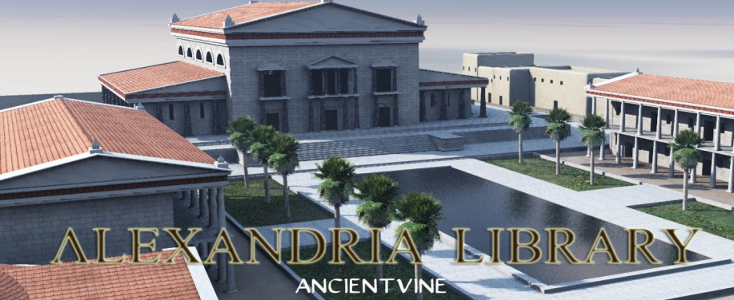
Library at Alexandria-developed as place of learning and blending of ideas and cultures

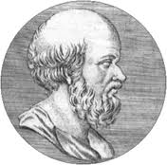
Eratosthenes- director of Library at Alexandria & closely estimated circumference of the Earth

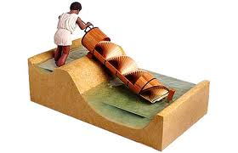
Archimedes Screw – applied scientific principles to make useful tools

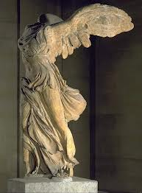
Nike of Samothrace – a very realistic depiction of a mythical creature/ realism was important

